Nailsea Newsletter
August 2021

Portishead, Clevedon and Nailsea Neighbourhood Policing
@ASPNorthSom

Nailsea Beat Team PCSOs
PCSO Andy GATENBY PCSO Chea SCANDRETT

Contact Details
andrew.gatenby@avonandsomerset.police.uk Nailsea Police Station, Pound Lane, Nailsea, BS48 2NN
chea.scandrett@avonandsomerset.police.uk Non Emergencies Call 101 and 999 for Emergencies

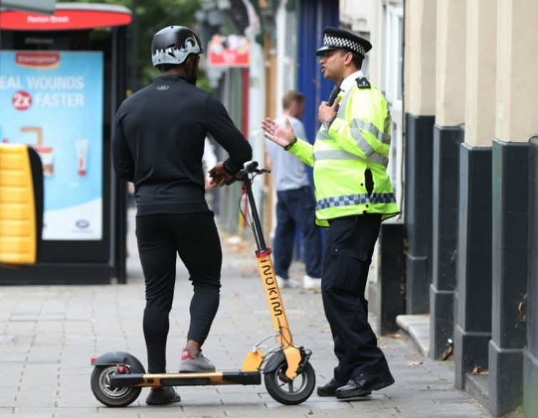
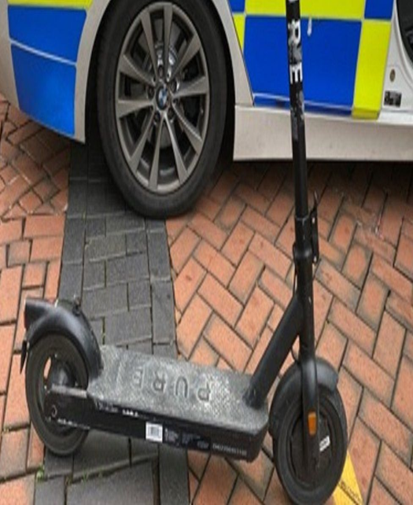
Electric scooters and the law
There have been incidents involving electric scooters reported to the beat team recently where they have been ridden in an antisocial manner. Electric scooters are also raising concerns nationally as there have been accidents involving both vehicles and pedestrians. Here are the most frequently asked questions and what you can do to help us deal with the issue -
Are electric scooters legal?
Yes, electric scooters are legal to own, however, there are lots of restrictions surrounding where they can be used.
Where can electric scooters be used?
The law as it stands states that electric scooters can only be used on private land. It is currently illegal to use them on public roads, on pavements, in cycle lanes and in pedestrian-only areas.
Why are electric scooters currently illegal on roads and pavements?
Electric scooters are currently classed as ‘powered transporters’ by the government and fall under the same laws and regulations that apply to all motor vehicles.
This means that it’s illegal to use them on pavements, in cycle lanes and in pedestrian-only areas such as Crown Glass Place. It would only be legal to use them on public roads if they could meet the same requirements as motor vehicles (e.g., in terms of insurance, tax, license, registration and vehicle construction), which in practice is virtually impossible.
The formulation of a law specifically covering electric scooters has been under discussion for some time. It looks like there may be some developments in this area soon, particularly with the rental trials currently taking place.
When will electric scooters become legal on roads and pavements?
Electric scooter rental trials have been underway in a number of areas across the UK since summer 2020. There has been a trial running in Bristol since October 2020. Local councils have been working with rental providers to test the viability of electric scooters as a safe and effective source of public transport.
What should I do if I see and electric scooter being ridden in Nailsea?
Please report any sightings to us. At this stage we wish to educate though if the problem persists, we have the option of fines of up to £300 and up to six penalty points on the driving licence. Serious offences could lead to driving disqualification and police can also impound the scooter.

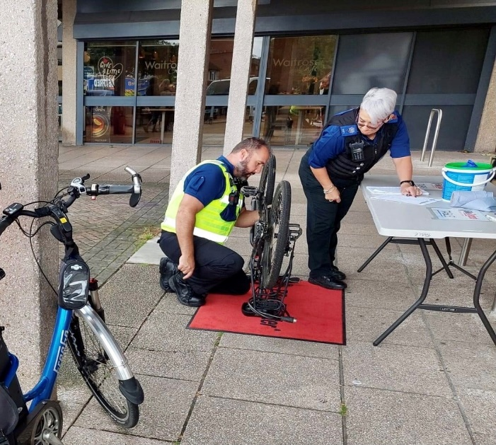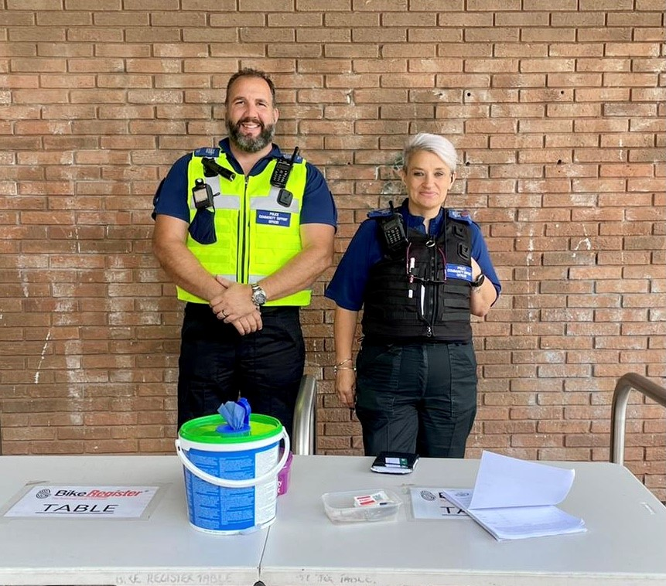
On Friday 6th August Chea and Sue held a bike marking event in the precinct which was very well attended. Dates of future events will be announced on our Facebook page. If you have not already done so you can follow all the Neighbourhood Policing Teams for dates of events including the Bike Register scheme.
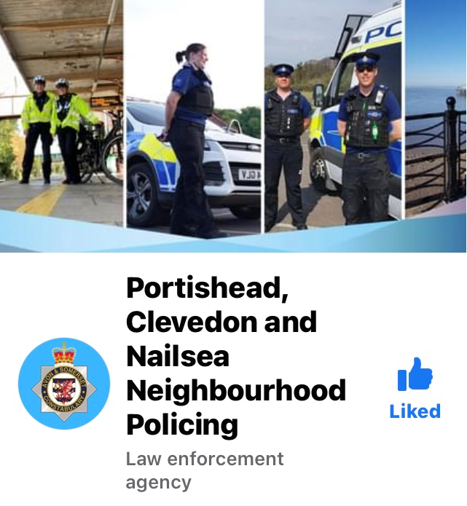

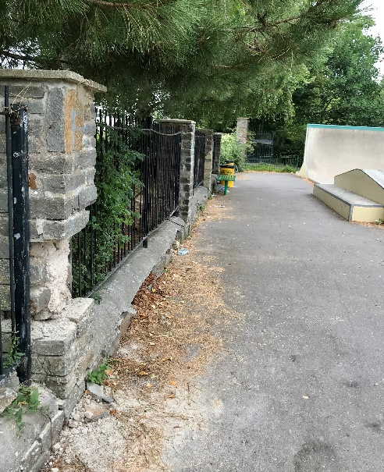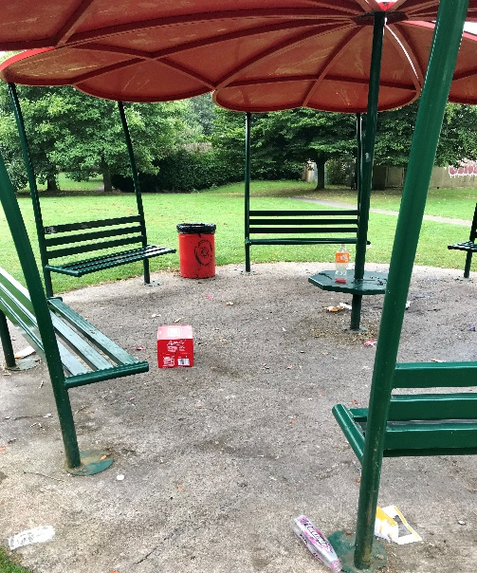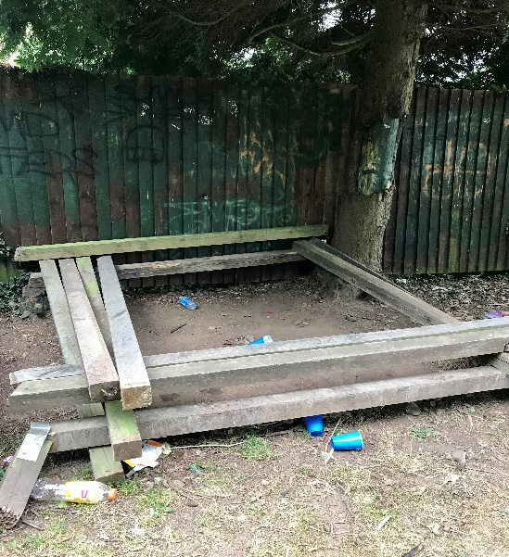
It has been very disappointing to see the criminal damage and littering that Millennium Park has suffered recently. We routinely patrol the park when duties permit and are working with Nailsea Town Council and North Somerset Council to alleviate the situation.
If you see groups gathered and have concerns about antisocial behaviour or the presence of drugs and alcohol, please contact us on 101 or email Andrew or Chea. We may not be on duty but it would be useful to know when incidents are occurring.
There is usually a spike in this sort of behaviour during August but we shall continue to monitor during September.

