Nailsea Newsletter
May 2021

Portishead, Clevedon and Nailsea Neighbourhood Policing
@ASPNorthSom

Nailsea Beat Team PCSO’s

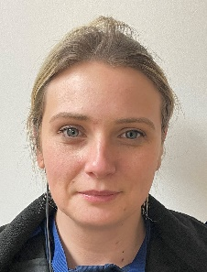
PCSO Amy HOLLAND PCSO Andy GATENBY PCSO Chea SCANDRETT

Contact Details
andrew.gatenby@avonandsomerset.police.uk Nailsea Police Station, Pound Lane, Nailsea, BS48 2NN
chea.scandrett@avonandsomerset.police.uk Non Emergencies Call 101 and 999 for Emergencies
amy.holland@avonandsomerset.police.uk Crimestoppers – 0800 555 111

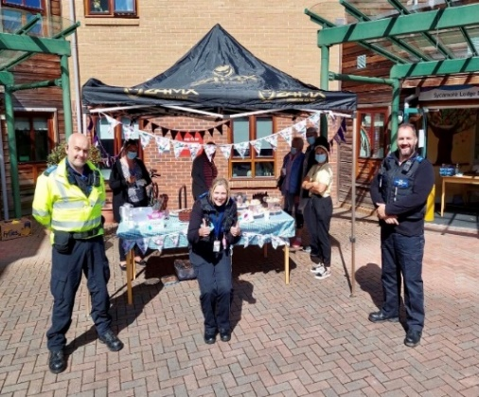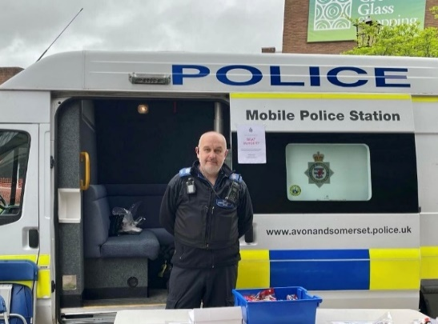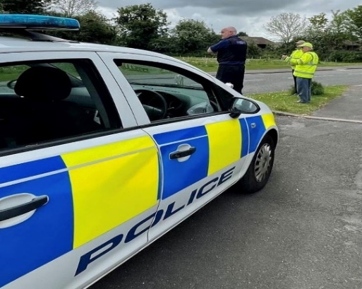
The month of May with the improving situation with regards to the Covid measures easing has seen the Nailsea Beat Team engaging in community events.
On Wednesday 5th May, Andy, Chea and Amy were pleased to attend Sycamore Lodge and their fundraising event for Dementia UK. The cakes were also most excellent.
We were also able to attend a Community Speedwatch session on Sunday May 16th to assist the volunteers who are giving their free time to help keep the roads of Nailsea safe.

Amy and Andy were also pleased to hold our first beat surgery of 2021 on Saturday 15th May which was very well attended. At the beat surgery we were continuing to promote the Facebook page which covers all of our policing areas. If you have not already done so, please visit.
We are holding another beat surgery on June 19th outside of Waitrose and running alongside the Farmers Market. Details will be announced on the Facebook page below –
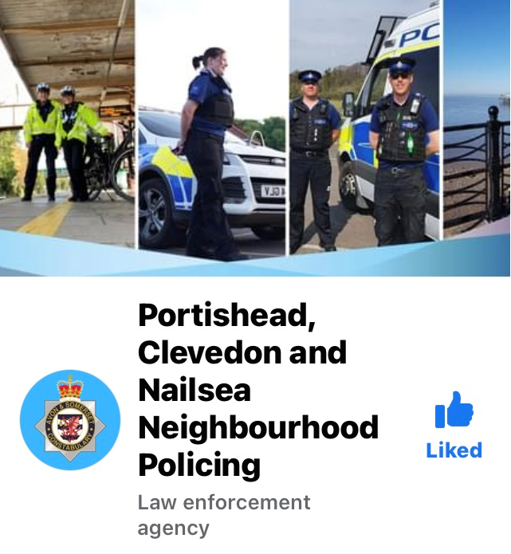

The flyers above have been found in various locations in Nailsea and brought to our attention. These flyers were stuck to a bus stop on Queens Road causing criminal damage to the shelter. Please let us know if you encounter any more of these items.

Important message from Nailsea Neighbourhood Watch Association.
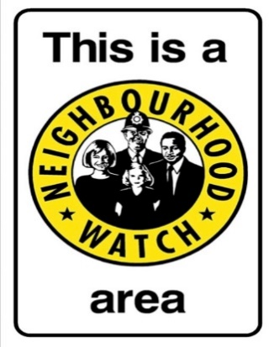
We have been struggling to be able to fill the following positions on the committee: Chairperson, Treasurer, Meetings Secretary, plus Committee Member (two needed).
If the required posts cannot be filled by 1st July 2021, we will have no option but to close the association on 31st July 2021.
If you can help in any way, please send an email to nailseanhw@gmail.com

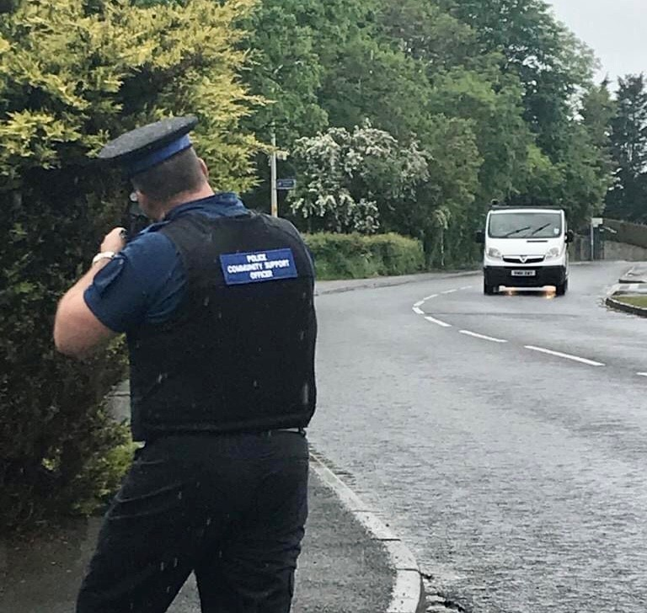
We have received several complaints from some resident’s reference speeding motorists at several locations in Nailsea.
People are concerned that the speeds are putting pedestrians at risk and that the more vulnerable members of the community have experienced some near misses while attempting to cross the road safely.
PCSO Chea attended one of these locations recently to monitor speeds and follow up and educate where necessary.
If you are concerned about this issue yourself then please consider joining Community Speedwatch.

Speedwatch serves as a deterrent through the high visibility presence but also as educational in that repeat offenders will receive a home visit from the beat team.
Simple training is provided and sessions can be very flexible time wise. This is a great way to contribute to the road safety of your community. If you are interested in becoming a volunteer or need more information email John.hunter77@btinternet.com

PCSOs | Area Covered
Nailsea Beat  PCSO Chea 7280  PCSO Andy 7268  PCSO Amy 6398 | - Nailsea  - Wraxall
Redwood Beat  PCSO Connor 9382  PCSO Olivia 9473 | - Flax Bourton  - Abbots Leigh  - Barrow Gurney  - Dundry  - Failand  - Felton  - Ham Green  - Pill  - Long Ashton  - Winford
Backwell Beat  PCSO Sue 8471 | - Backwell  - Cleeve
Yeo Vale Beat  PCSO Kate 7948  PCSO Julie 9779 | - Congresbury  - Wrington  - Langford  - Blagdon  - Hewish  - Puxton

