HOTEL BRISTOL BERLIN



**Welcome to Hotel Bristol Berlin!**

Bristol Berlin is a vibrant, legendary hotel on *Kurfürstendamm*. Formerly named Hotel Kempinski, it was Berlin’s first postwar, new luxury hotel, opening its doors in 1952 to welcome the *Wirtschaftswunder (economic miracle)*. Hollywood stars and renowned politicians slept here, from John F. Kennedy to Liza Minelli to Sir Alfred Hitchcock. Prior to WWI, *Kurfürstendamm* 27 was a renowned restaurant and delicatessen, the celebrated heart of Kempinski Berlin.

Kurfürstendamm 27 | D-10719 Berlin | www.bristolberlin.com

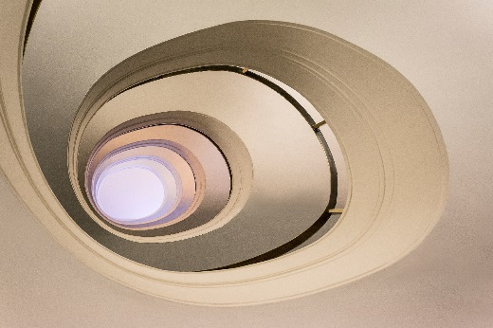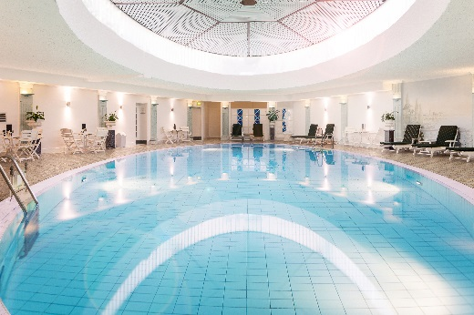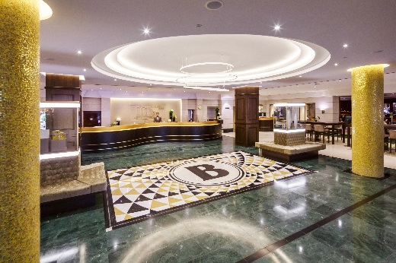

**HOTEL BRISTOL BERLIN –** LIVINGHISTORY

**SPIRAL STAIRCASE**

On January 23, 1969, our heritage-protected spiral staircase was the scene of celebrity significance. Sparks flew when Jimi Hendrix and Uschi Obermaier met here for the first time. The rest is history.

**OUR POOL & SAUNA**

We opened our hotel pool & sauna domain in 1974 and the warm waters were wonderful for Herbert von Karajan’s minor aches and pains.

The feel-good domain was completely renovated in 2017 and an additional infrared sauna installed. Pamper yourself in your free time, take a dip in the pool or enjoy a relaxing massage.

**BRISTOL BAR**

For our guests and local society, the Bristol Bar has always set the tone for Berlin night life. Modern art beneath venetian overhead lighting creates a lively ambience. Caipirinha, just one of our 200 cocktails, is Number 1 on the cocktail menu. Enjoy the elegance of cigar-smoking culture with our excellent selection of elite tobaccos.

**BRISTOL CAFÉ**

In June of 1998, the Gobelin Hall was opened, offering an alternative to our Garden Restaurant. In the wake of lobby renovations in 2017, the Gobelin Hall was renewed and renamed as the Bristol Café. A wonderful place to relax, meet friends or express your creativity, it’s no wonder Bristol Café was quickly named *Berlin’s most inviting living room*.

**BRISTOL GRILL**

Maximilian Schell, Roger Moore, Harald Juhnke and many other stars were regular customers at Berlin’s famous gourmet restaurant, and when the Kempinski Grill reopened on January 5, 1998, the legend lived on. Today, the Grill continues to be one of the city’s most exquisite dining addresses. Culinary regional specialties, seasonal delights and international dishes grace the regularly variating menu.

**EVENTS**

Hotel Bristol is an impeccable event location, offering you optimal options for your next conference or celebration. Designed to inspire, our modern venues are open for your creativity and make your meeting a success.

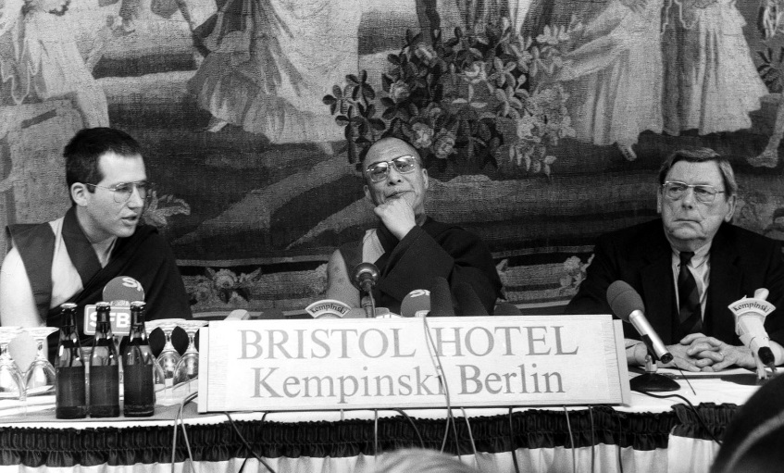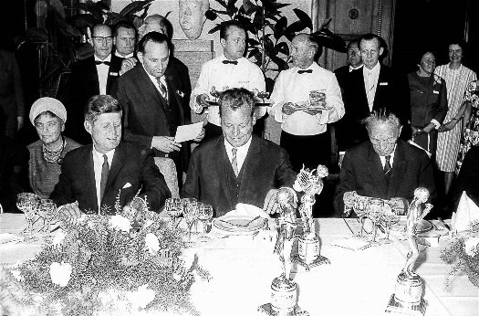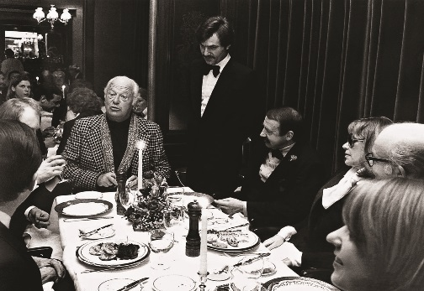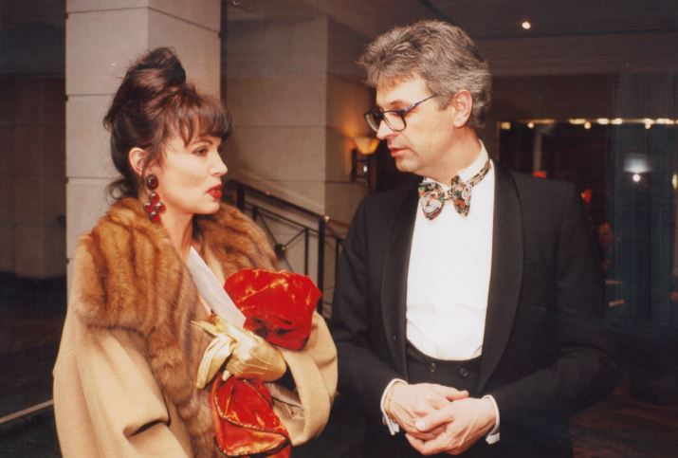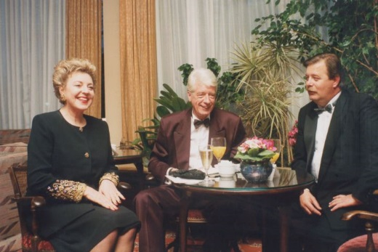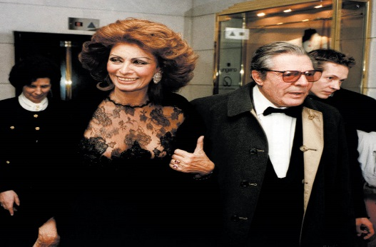

We are always delighted to welcome back loyal **Hotel Bristol Berlin** guests. Many of our regulars bear well-known names, such as …

Prinzessin Stephanie von Monaco

Professor Dr. Werner Heisenberg

Rockefeller

Roger Moore

Romy Schneider

Ronald Reagan

Rudi Carell

Ruth C. Unger-Kempinski

Sarah Fergusson

Sir Alfred Hitchcock

Sophia Loren

Status Quo

Steven Spielberg

Thomas Gottschalk

Thomas Mann

Tina Turner

Ursula van der Leyen

Uschi Glas

Verona Pooth

Walt Disney

Wayne Carpendale

Willy Brandt

Xavier Naidoo

Albert Einstein

Axel Springer

Ben Kingsley

Birgit Fischer

Christiane Hörbiger

Christina Gardiner

Chuck Berry

Curd Jürgens

Dagmar Berghoff

Dalai Lama

Danny de Vito

Dr. Helmut Kohl

Dr. Roman Herzog

Erich Kästner

Erich Maria Remarque

Eva Padberg

Fady Maalouf

Fidel Castro

Franz Beckenbauer

Fritz Walter

Gudrun Landgrebe

Haim Ramon

Hape Kerkeling

Harry Wijnvoord

Hildegard Knef

Indira Gandhi

Ingrid Bergmann

Iris Berben

Isabel Edvardsson

J.F. Kennedy

Jack Nicholson

Jamie Oliver

Joan Collins

Johnny Depp

Jürgen Tarrach

Jutta Speidel

Kirk Douglas

„Kool and the Gang“ Charles E.

Marcus Schenkenberg

Margaret Truman

Marie Lusise Marjan

Max Schmeling

Michael Douglas

Mikhail Gorbachov

Mick Jagger

Nazan Eckes

Nena

Nina Ruge