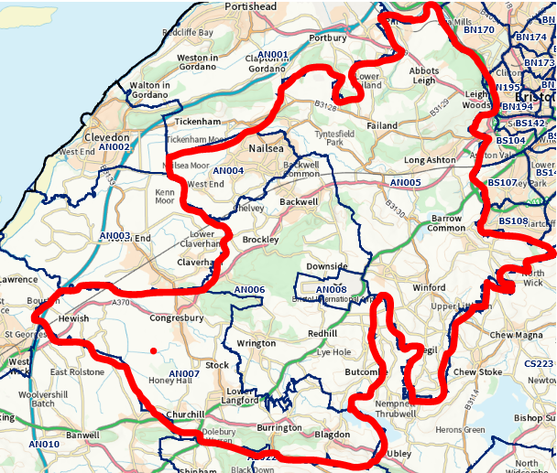

YOUR NEIGHBOURHOOD TEAM
November 2022

NEWS IN YOUR AREA
Introduction
It’s been a while since I provided a formal update like this, or as formal as I get at least. This was in part due to the restrictions summer demand places on us; my home time I usually spent writing these were actually spent reviewing crimes… but as staff return to the Neighbourhood Policing nest I feel I should be getting back into these updates… and the nest is a bit more crowded now.

For we have a new PCSO, Craig Dunbar, who joins us and will be covering the Yeo Vale/Wrington beats. He’s just finished his first week under Kate’s wing and is already proving to be an exceptional recruit. We also have Matt Richardson learning the ropes here before heading over to the Clevedon/Portishead team. They are both superb and will add a huge amount to the area I am sure.

We are soon to lose Gary Marriott and Andy Gatenby, both leaving the organisation following fantastic careers in the job over many years. They have been great public servants and have earnt our thanks. We all hope they are hugely successful in their lives outside Avon and Somerset Constabulary.

I hope the update provides you with a bit of an insight into our work and, as the supermarket displays start to make you realise Christmas is on the horizon, assure we are there to help people keep safe during what we know has been a challenging and no doubt stressful time for many. We see the struggles and issues people face so please know if you need us, we will do our best for you.
Your Policing Team

Police Officers:
PS 2781 Lee KERSLAKE
(07889 656025)

A/PS 3467 Paul LEWIS
PC 1954 Bridget GRIFFITHS
PC 4469 Justina LEWIS
PC 4175 Gary MARRIOTT

Police Community Support Officers:

PCSO 7280 Chea SCANDRETT
PCSO 8999 Dan JACKSON
PCSO 7948 Kate TURNER
PCSO 9382 Connor AITKEN
PCSO 9146 Craig DUNBAR
PCSO 8471 Sue HAWKINS
PCSO 6398 Amy HOLLAND
PCSO 7268 Andy GATENBY

CSW Coordinator – Jon Hunter

Get in touch

In an emergency always call 999

For non-emergency matters call us on 101 or report online via www.avonandsomerset.police.uk/
report

To report a crime anonymously, contact Crimestoppers on
0800 555 111 or visit
www.crimestoppers-uk.org

Get in touch

In an emergency always call 999

For non-emergency matters call us on 101 or report online via www.avonandsomerset.police.uk/
report

To report a crime anonymously, contact Crimestoppers on
0800 555 111 or visit
www.crimestoppers-uk.org

Public Nuisance - Cleeve
High Risk Offender Charged

Following an extensive investigation by our own PC Bridget Griffiths, an individual assessed as high risk of offending has been charged for harassment offences against 9 victims in and around the Nailsea Area, with conditions placed on him restricting the contact he can have with those he posed a risk to.

Bridget worked with a large number of victims to understand the issues and identified an offender who was emerging as a problem for a number of local residents, with whom he had direct or indirect links. There is no wider community risk.

A number of statements, interviews and work with the CPS led to a positive charging decision, alongside using our other powers to place conditions on him prohibiting him from contacting victims and some local business employees.

This male also has his own challenges and alongside the investigation Bridget worked tirelessly to ensure that they were addressed, working with partners to provide a placement that ensures greater supervision over his activity.

Where people cause a risk to the community, we not only investigate and deal with offences, but we look at why the offending is occurring and work with our partners and those able to influence these issues. This was a fantastic indictment of the benefits of such an approach and the phenomenal talent we have within our team in Bridget.

You will most likely have seen a news item in the local and national press regarding a male arrested for public nuisance in Cleeve recently. The incident itself related to a call from the public in relation to a male dressed in dark clothing and full face covering. Officers reacted quickly to the call and an arrest was made that night. Whilst there was no physical risk to the public we are very aware that you expect your local Police to respond quickly to issues that cause the public concern and the speed at which officers responded to this hopefully provides reassurance that we are committed to doing just that. As we have any updates we can share we will of course do so, but please be assured that we continue to patrol the locality and do all we can to ensure the area continues to remain the safe area that it is.

Persistent Calling…
We have been working with a person from Wrington who has support needs that often caused them to contact the Police.

In fact, they have called us over 1000 times in the third quarter of the year, making them one of the highest callers, at one point the highest, in the Constabulary. These calls were consistently inappropriate for policing, however was evident of the extent of their needs. Our work is often trying to help people get the support they need and, alongside their GP, family and other support agencies they have been in a much better state and has not called the police for approaching 2 months.

We get a lot of calls as a result of mental health issues that can take a huge amount of resource and this can bring about polarising views. Ours is that where people need help we will do out utmost to ensure it is provided to them.

Shoplifter - Cleeve
We are currently investigating a persistent shoplifter in the Cleeve, Langford and Congresbury areas. Our team are working with local businesses to ensure we bring this person to justice.

If you are a local business suffering from an individual or individuals who are persistently targeting your stores please let us know. I am aware that some make judgements about the policing response to such issues prior to calling us, or preventing reporting of issues.

It is only by knowing about those causing persistent harm that we can do anything about them…
Intray Snapshot
The above provides a little bit of detail on some of the things done over the last month… but here’s a few more:

Missing Person - Congresbury

Our team last week located a missing 13 year old who went missing from Congresbury having walked all the way to Nailsea. We returned this individual to their home address where we had a discussion about their issues and handling stresses going forward. The discussion was a very positive one and hopefully we influence them in future. If you have young people who you are concerned about and feel would benefit from a discussion with us before it becomes a discussion with the police after a criminal incident (either victim or offender), let me know… it’s one of the reasons our team exists… lee.kerslake@avonandsomerset.police.uk

Nailsea – Problem Individuals and ASB

We have over the last month been dealing with a few repeat individuals causing issue in the centre. There was fire and damage to a door in two separate issues in the High Street. We have identified a suspect and have interviewed them. We are seeking a charging decision on these matters, whilst addressing the issues that sit behind them. We have also placed conditions banning them from the town centre in the evenings and have secured their place on a Local Authority support programme seeking to get them back into housing and work.

We also have another individual who has been heavily intoxicated and causing issues for local residents and young people in the town centre. We are working with this person and their support network to address their issues whilst also dealing with them for offences.

Congresbury – ASB Issues

We have continued to patrol Congresbury and have dealt with individuals for both group ASB issues, alongside a male identified to be abusing members of the public in public areas. This person has been issued with conditions surrounding their behaviour in public and will be monitored by both our team and the Local Authority who have worked with us to secure these conditions.

Road Safety across our area

Our team now has members trained on a portable calibrated speed gun. This will enable our team to provide short and sporadic speed enforcement sessions in areas highlighted as significant issues for us. This flexibility will improve our ability to tackle road safety issues. We will also be targeting local licensed premises identified as drink driving hotspots.
New PCSO – Use Him…

Our new PCSO needs experience in community events and groups… we will show him the ropes as we see it but I always think these times are great opportunities to involve you…

If you have groups, events, things you think our new PCSO Craig (or Matt) would benefit from being part of, let me know.

A new PCSO has fresh views on the world and can be a bit of a blank canvas… I always like to see the community paint a bit on it…

lee.kerslake@avonandsomerset.police.uk

Services

We can offer services that you may find useful for your group or area:

- Crime Prevention
- Person Centred Problem Solving
- Neighbourhood Policing
- Intelligence and Policing
- Policing North Somerset
- Introduction to your local policing team

Just let us know if any are of interest, or we can discuss anything that may be of use

lee.kerslake@avonandsomerset.police.uk

